

**SOFTWARE REQUIREMENT SPECIFICATION (SRS) SIGN-OFF**

**Authorization Memorandum**

This form is to sign-off completion of the Requirement Phase for **CAMPUS MANAGEMENT SOFTWARE AT WORLD SKILL CENTER (WSC).**

World Skill Centre (WSC) acknowledges receipt of the deliverables as part of the Requirement Phase through the submission of this document.

|  |  |
| --- | --- |
| **MODULE NAME** | **Scholarship Module** |

| **VERSION HISTORY** | | | |
| --- | --- | --- | --- |
| **Version** | **Author** | **Date** | **Changes** |
|  |  |  |  |
|  |  |  |  |

**WSC AUTHORITY NAME AND**  **SIGNATURE**

**SOUL AUTHORITY NAME AND**  **SIGNATURE**

Pages 1 of 10



**Sustainable Outreach And Universal**

**Leadership (SOUL) Limited**

**Software Requirement Specification (SRS)**

Of

**Scholarship Module**

For Implementation of

**Campus Management Software**

at

**World Skill Center (WSC)**

**Table of Content**

A. Abstract 3

B. Introduction 3

C. Definition, Acronyms and Abbreviations 3

D. Overview of the Document 3

E. Scope of Education Module 4

E. WSC Scholarship Process Flow 4

F. Process Flow Description 5

G. List of Screens and Their Descriptions 5

H. Scholarship 6

1. Scholarship 6

2. Scholarship Application 7

# Abstract

Software Requirements Gathering is one of the first phases of system development. This phase results in the Software Requirements Specification (SRS) document, which must contain a complete, concise, high-quality description of the system being considered.

# Introduction

The World Skill Center (WSC) is a premier advanced skill training institute established by the Government of Odisha, Skill Development and Technical Education Department, through the Odisha Skill Development Authority (OSDA). The WSC will impart advanced skill training in eight trades from engineering and service sectors. WSC caters primarily to induct the best talent from ITIs and Polytechnics and train them to become globally employable in emerging areas such as "Industry 4.0". WSC is housed in a state-of-the-art, 18-storey, air-conditioned building with nearly half a million square feet of space in the heart of capital city of Bhubaneswar.

With the Implementation of campus management software for WSC the goal is to streamline the operations and functions of the campus by integrating various processes, such as admissions, course registration, academic progress tracking, and financial management, HRMS, Procurement and Inventory management, etc into a unified system. The implementation also aims at providing a user-friendly interface for all stakeholders, making it easier for them to access the necessary information and complete their tasks with ease. The modules to be covered during the implementation of the software includes:

|  |  |
| --- | --- |
| Students Management Modules | Infrastructure Management |
| Academic System | Finance and Accounting System |
| Procurement & Inventory Management | Training and Placement |
| Human Resources Management System | Application Integration |

# Definition, Acronyms and Abbreviations

The following table explains the terms and abbreviations used in the document:

|  |  |
| --- | --- |
| **Abbreviation** | **Description** |
| SRS | Software Requirements Specification |
| SLCM | Student Life Cycle Management |
| R | Rename - When a field is Renamed |
| N | New - When a New field is Added |
| D | Delete - When an Existing field is Deleted |
| NA | Not Applicable |

# Overview of the Document

This requirement document provides a detailed overview of the functional requirements of a project. It serves as a communication tool between stakeholders, including developers, project managers, and end-users. The purpose of this requirement document is to define and document the project's objectives, scope, and expectations, and to ensure that all stakeholders have a clear understanding of what the project entails.

This document covers all the functional requirements of the **Education Scholarship module** of ERP Product. This module helps in organizing the entire Scholarship set-up, such as Student Database, Scholarship Structure, Scholarship Application Form, etc.

# Scope of Education Module

* Courses and Subjects, Timetable preparation and management  ▪
* Class occurrence monitoring
* Class Attendance of students (Face recognition or any other automated mode).    ▪
* Results Analysis after declaration of results by WSC ▪
* Students Feedback mechanism on quality of teaching learning ▪ Internship, Training, Apprentice ▪
* Students Profile: Personal Information, Contact Details, Academic Details.
* Re-Admission Process after discontinuing in studies
* Issue of Identity Card
* Faculty Workload / Lesson Plan
* Rewards and achievements.  ▪
* Re-Admission Process after discontinuing in studies ▪
* Students Back paper tracking etc.
* Students Profile.  :Personal Information, Contact Details, Academic Details ▪
* Issue of Identity Card.  ▪
* Biometric Attendance (Face recognition) ▪
* Hostel Management (Hostel seat allotment, attendance, fees etc) ▪
* Scholarships.  ▪
* Rewards and achievements.  ▪
* Students’ Evaluation/remarks of Faculty.  ▪
* Students Exams records of all 6 semesters ▪
* Parent Enquiry/Alert/Messaging Management.  ▪
* Messaging System  ▪
* Students Grievance System etc.

Following functionalities are covered in this SRS document:

* **Scholarship**

# WSC Scholarship Process Flow

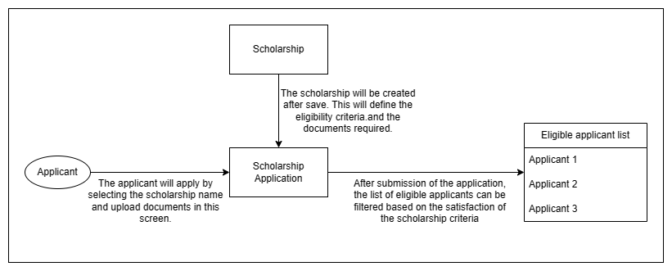

Figure 1 : Scholarship Process Flow

# Process Flow Description

**Scholarship:**

In the scholarship screen, the user will be maintaining all the required criteria and the documents names which are necessary for the scholarship application. This screen will be linked with the Scholarship Application screen and will facilitate the shortlisting of students eligible for scholarship.

**Scholarship Application :**

This screen will maintain the scholarship student applicants' records which will include their names, family income, documents, etc.

# List of Screens and Their Descriptions

|  |  |  |
| --- | --- | --- |
| **Sl no** | **Screen Name** | **Description** |
|  | Scholarship | This is a master screen for Scholarship Application where the user can maintain the scholarship criteria and list of documents required for the scholarships. |
|  | Scholarship Application | The Scholarship Application screen will help the user maintain applications for eligible scholarship applicants which will be further used for review and selection process. |

# **Scholarship**

## Scholarship

**General Description**

|  |  |
| --- | --- |
| **Description** | This is a master screen for Scholarship Application where the user can maintain the scholarship criteria and list of documents required for the scholarships. |
| **Navigation** |  |
| **Pre-requisites** | The system should have records in the following screen   1. Scholarship Company 2. Academic Year 3. Document Template |

**Screenshot**

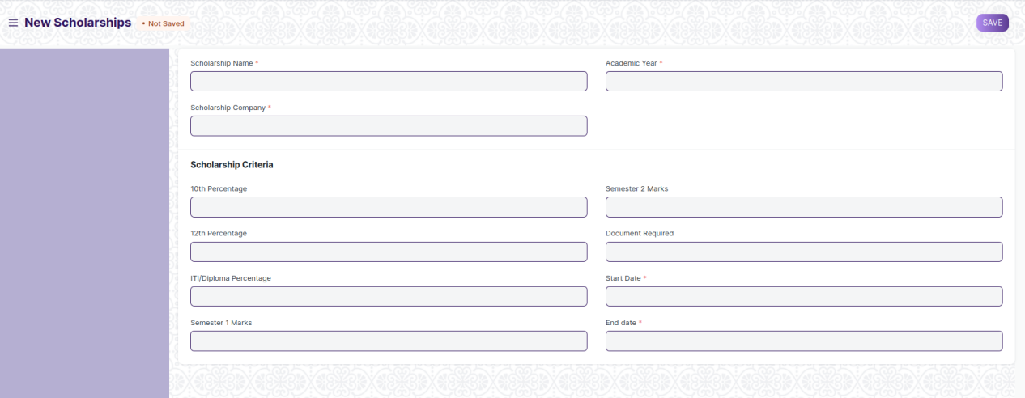

Figure 1: Scholarship Screen

**Field list**

The following table describes the UI fields present on this screens:

|  |  |  |  |  |  |  |
| --- | --- | --- | --- | --- | --- | --- |
| **ID** | **Field Name** | **Field Type** | **Validation/Action** | **Mandatory** | **Remarks** | **R/N/D** |
| 1 | Scholarship Name | Text | User Input | Y |  |  |
| 2 | Scholarship Company | Link | Fetched from Company master | Y |  |  |
| 3 | Academic Year | Link | Fetched from Academic Year Master | Y |  |  |
| **Scholarship Criteria** | | | | | | |
| 4 | 10th Percentage | Percent | User Input |  |  |  |
| 5 | 12th Percentage | Percent | User Input |  |  |  |
| 6 | ITI/Diploma Percentage | Percent | User Input |  |  |  |
| 7 | Semester 1 Marks | Float | User Input |  |  |  |
| 8 | Semester 2 Marks | Float | User Input |  |  |  |
| 9 | Document Required | Link Field | Fetched from Document Template Master |  |  |  |
| 10 | Start Date | Date Picker | User Input | Yes |  |  |
| 11 | End date | Date Picker | User Input | Yes |  |  |

**Users: Roles and Permissions**

The following table describes the users and their roles and permissions for the screens:

|  |  |  |  |  |  |  |  |  |
| --- | --- | --- | --- | --- | --- | --- | --- | --- |
| ID | Role | Read | Write | Create | Delete | Submit | Cancel | Amend |
| 1 | Education Academic Head | Yes | Yes | Yes | Yes | Yes | Yes | Yes |

## Scholarship Application

**General Description**

|  |  |
| --- | --- |
| **Description** | The Scholarship Application screen will help the user maintain applications for eligible scholarship applicants which will be further used for review and selection process. After submission of the application form on click of submit, the status of the application will be auto updated to eligible or not eligible based on the criteria of the scholarship selected, which was defined in the Scholarship master screen.  The Education Academic Head user can now export the student records of all the eligible students in CSV/Excel format. |
| **Navigation** |  |
| **Pre-requisites** | The system should have records in the following screen   1. Student applicant 2. Scholarship master records. |

**Screenshot**

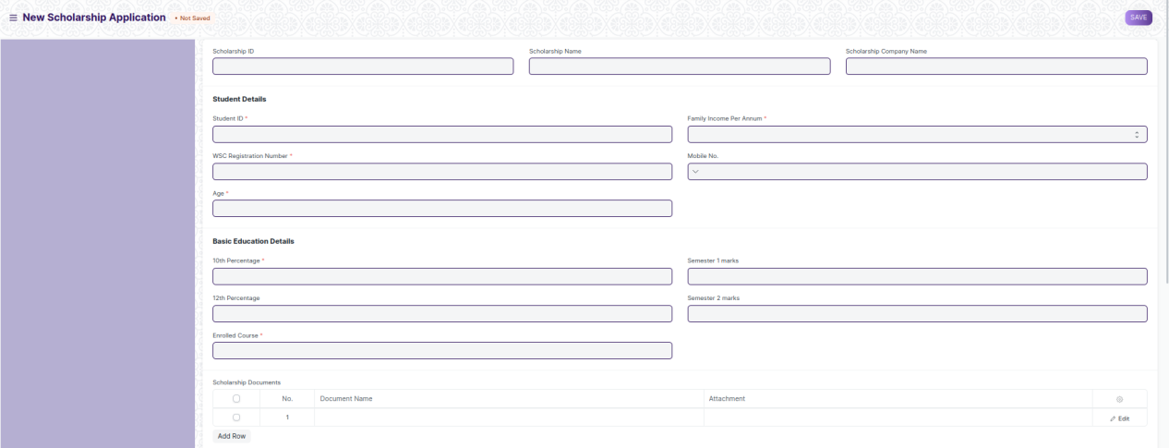

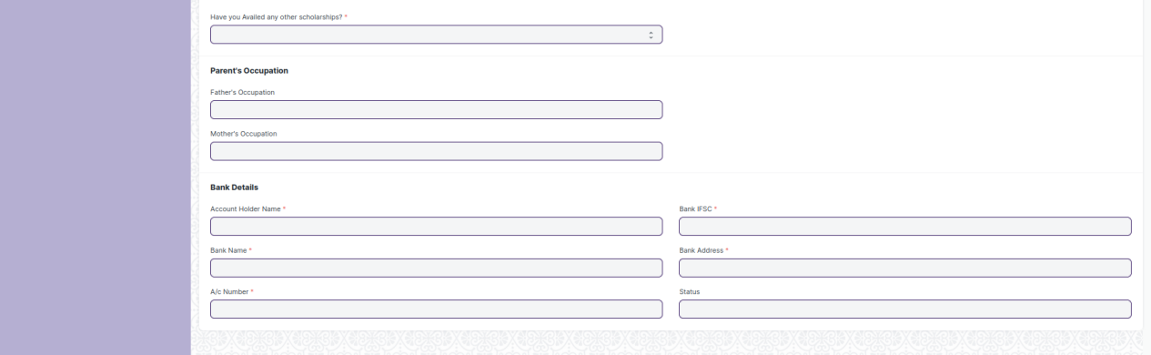

Figure 2: Scholarship Application Screen

**Field list**

The following table describes the UI fields present in this screens:

|  |  |  |  |  |  |  |
| --- | --- | --- | --- | --- | --- | --- |
| **ID** | **Field Name** | **Field Type** | **Validation/Action** | **Mandatory** | **Remarks** | **R/N/D** |
| 1 | Scholarship ID | Link | Fetched From Master Screen Scholarship |  |  |  |
| 2 | Scholarship Name | Text | Auto Fetch Based on Scholarship ID |  |  |  |
| 3 | Scholarship Company | Text | Auto Fetch Based on Scholarship ID |  |  |  |
| 4 | Student ID | Link | Fetched From Master Screen Student | Yes |  |  |
| 5 | Name of the Student | Text | Auto fetch based on Student ID |  |  |  |
| 6 | WSC Registration No. | Text | Auto Fetched From Master Screen Student | Yes |  |  |
| 7 | Age | Number | Auto Fetched From Master Screen Student |  |  |  |
| 8 | Family Income per Annum | Drop Down | Below 1.25 Lakh  1.25 - 2.5 Lakh  2.5 - 3.5 Lakh  3.5 - 4.5 Lakh  4.5 - 5.5 Lakh  5.5 - 6.5 Lakh |  |  |  |
| 9 | Mobile Number | Phone | User Input, should not be more or less than 10 digits | Yes |  |  |
| **Basic Education Details** | | | | | | |
| 10 | 10th Percentage | Percent | Auto Fetched From Master Screen Student | Yes |  |  |
| 11 | 12th Percentage | Pecent | Auto Fetched From Master Screen Student |  |  |  |
| 12 | WSC Course Enrolled | Link | Fetched from Master screen Course |  |  |  |
| 13 | Semester 1 marks | Number | Auto Fetched From Master Screen Student |  |  |  |
| 14 | Semester 2 marks | Number | Auto Fetched From Master Screen Student |  |  |  |
| 15 | **Scholarship Documents** | Table |  | Yes | Fields described in the table below |  |
| 16 | Have you Availed any other scholarships? | Drop down | Yes  No | Yes |  |  |
| **Parent’s Occupation** | | | | | | |
| 17 | Father’s Occupation | Text | Auto Fetched From Master Screen Student |  |  |  |
| 18 | Mother’s Occupation | Text | Auto Fetched From Master Screen Student |  |  |  |
| **Bank Details** | | | | | | |
| 19 | Name of Account Holder | Text | User Input | Yes |  |  |
| 20 | A/c Number | Number | User Input | Yes |  |  |
| 21 | Bank Name | Text | User Input | Yes |  |  |
| 22 | Bank IFSC | Text | User Input | Yes |  |  |
| 23 | Bank Address | Text | User Input | Yes |  |  |
| 24 | Status | Text | Auto updated based on the the Scholarship criteria |  |  |  |

|  |  |  |  |  |  |  |
| --- | --- | --- | --- | --- | --- | --- |
| **Scholarship Documents** | | | | | | |
| **ID** | **Field Name** | **Field Type** | **Validation/Action** | **Mandatory** | **Remarks** | **R/N/D** |
| 1 | Document Name | Drop Down | 10Th Certificate  Income Certificate  Caste Certificate  Residence/Domicile Certificate |  |  |  |
| 2 | Attach | Attach Button | A dialog box will appear where the applicant will upload the required documents. |  |  |  |

**Users: Roles and Permissions**

The following table describes the users and their roles and permissions for the screens:

|  |  |  |  |  |  |  |  |  |
| --- | --- | --- | --- | --- | --- | --- | --- | --- |
| ID | Role | Read | Write | Create | Delete | Submit | Cancel | Amend |
| 1 | Education Academic Head | Yes | Yes | Yes | Yes | Yes | Yes | Yes |
| 2 | Account Manager | Yes | No | No | No | No | No | No |
| 3 | [Student](http://localhost:8000/app/permission-manager/Photocopy Application)(Only if creator) | Yes | Yes | Yes | No | Yes | No | No |
| 4 | [Student](http://localhost:8000/app/permission-manager/Photocopy Application)(After Submission) | Yes | No | No | No | No | Yes | No |